**Week13 Assign Group: Group Project**

**User’s Guide**

Upon loading the program, the user will see the one single solitary screen of this project.

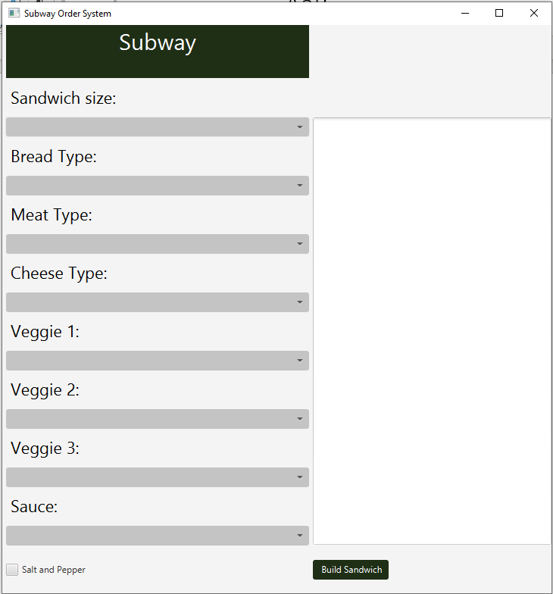

Using the combo boxes, the user will click the down arrow.

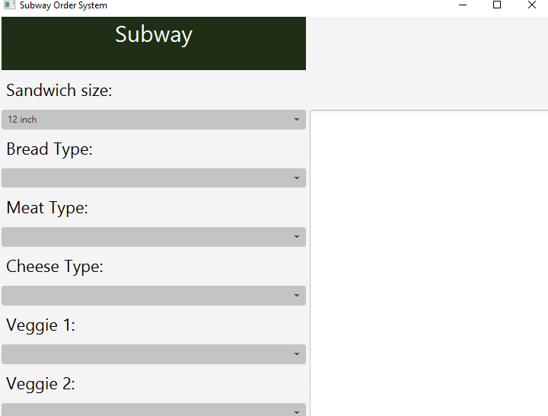

That will open the combo box and display the ingredient options.



White

Wheat

Monterey Cheddar

Using left click of the mouse, the user will make their single selection from each box. Once they do it will fill the box with their selection.

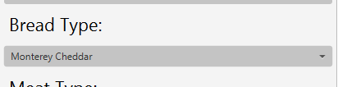

Once the user has made a selection for each ingredient they would like on their sandwich from the combo boxes, they can select the “Salt and Pepper” check box if they would like salt and pepper on their sandwich, or leave it unchecked if they don’t.

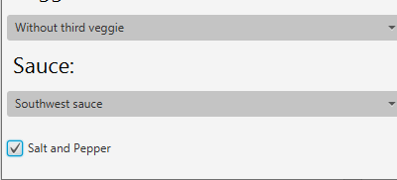

When all of the boxes that the user desires to have on their sandwich has been filled, they can left click on the “Build Sandwich” button.

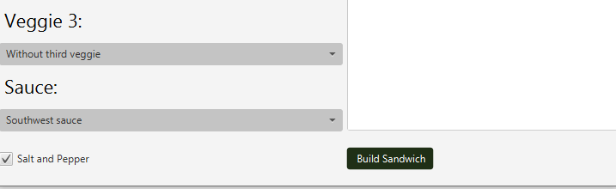

And that will show them a recap of which ingredients they have selected on their sandwich inside of the text area box.

